|  |  |
| --- | --- |
| Team 1 – Lifecycle Justification  and Process Plan | Ivan, Natalia, Ronan  Software Design with AI for Cloud Computing 3.1 |

# Justification

Our team decided to go for Incremental Delivery, reasons why:

1. **Requirements are well defined** - this allows us to divide the project into smaller phases which we will deliver in increments. Our plan was to pick key increments that would be presented to customer so we can gain valuable feedback and ensure needs are met.
2. **Feedback** - as we want to include customer input/feedback at key moment of development (which will be highlighted in the plan), incremental delivery will allow us to present work done to customer. This will also ensure we can incorporate changes at earlier stage if needed.
3. **Supports changes to some extent** – Incremental Delivery is a Plan Driven approach that assumes nothing should change. Although, it doesn’t mean the scope cannot change between increments when required. In the lifecycle we choose, the increments are planned in advance although we still have benefit of making small tweaks if necessary.
4. **Development Process** - it is more visible how much has been done and what’s left to do as each increment is completed and delivered. As we will choose key phases that customer will be involved in, it will be reassuring for them.
5. **Phased Development** – development is done sequentially, where each increment is building up on the previous one. This also doesn’t mean we must cross out parallel development. We can have two developers working on two different increments simultaneously. This will ensure deadline is met and if we are ahead of time, we will have either more time for testing or supporting another developer.
6. **Product Availability** – Incremental Delivery allows us to have working software quicker, which can provide value to customer sooner. It for sure will not be a fully working product after first delivery, although some functionality can be available to customer easier (eg. signing up new users into the system)
7. **Testing** – testing is involved with each increment, which ensures high quality of software is delivered to customer. We also are not moving to the next increment until everything is fully working.

We have decided not to go for Agile as requirements are well-defined and we don’t need to involv4e customer constantly. Instead, we will present what we have at its key phases. We also rejected Waterfall due to it’s total lack of flexibility. It is highly sequential model, where each phase is dependant on the previous one. We wouldn’t be able to have two devs working on separate phases as everything happens one after another. Here, we also don’t have customer input until the end which can potentially make it very costly to revise/fix if there are issues. We also rejected V-Model as the team is too small to take that approach. It requires extensive testing and parallel working which we don’t have resources for. It would potentially add extra complexity to the project.

# Process Plan

|  |  |  |  |  |  |
| --- | --- | --- | --- | --- | --- |
| Increment | Task | Description | Assignee | Estimation | Week |
| Increment 1   1. Initial Planning 2. Specification 3. Design | Team Setup | Prepare working agreement, create/clone team repo | Natalia Ronan Ivan | 4h x each | WK 3 |
| User Stories | Admin, Newsagent, Delivery Doc | Natalia | 4h | WK 3-4 |
| Delivery Driver, Publication (book) | Ronan |  | WK 3-4 |
| Invoice, Cust Subscription | Ivan |  | WK 3-4 |
| Process Planning | Design UML for User Stories, design tests | Natalia |  | WK 3-4 |
| Ronan |  | WK 3-4 |
| Ivan |  | WK 3-4 |
| System Architecture | Describe system architecture | Natalia | 2h | WK 4 |
|  | Ronan |  |  |
| Create flow chart | Ivan |  |  |
| Increment | Task | Description | Assignee | Estimation | Week |
| Increment 2 | Create Database | Create customer, delivery doc, newsagent database | Natalia | 2h | WK 4 |
| Increment 2 | Create delivery driver, publication database | Ronan |  | WK 4 |
| Increment 2 | Create invoice, cust subscription database | Ivan |  | WK 4 |
| Increment 2 |  |  |  |  | WK 5 |
| Increment 2 |  |  |  |  | WK 5 |
| Increment 2 |  |  |  |  | WK 5 |
| Increment 2 |  |  |  |  | WK 6 |
| Increment 2 |  |  |  |  | WK 6 |
| Increment 2 |  |  |  |  | WK 6 |
| Increment 2 |  |  |  |  | WK 6 |
| Increment 2 |  |  |  |  | WK 6 |
| Increment 2 |  |  |  |  | WK 6 |
| Increment 3 |  |  |  |  | WK 7 |
| Increment 3 |  |  |  |  | WK 7 |
| Increment 3 |  |  |  |  | WK 7 |
| Increment 3 |  |  |  |  | WK 7 |
| Increment 3 |  |  |  |  | WK 7 |
| Increment 3 |  |  |  |  | WK 7 |
| Increment 4 |  |  |  |  | WK 8 |
| Increment 4 |  |  |  |  | WK 8 |
| Increment 4 |  |  |  |  | WK 8 |
| Increment 4 |  |  |  |  | WK 8 |
| Increment 4 |  |  |  |  | WK 8 |
| Increment 4 |  |  |  |  | WK 8 |
| Increment 5 |  |  |  |  | WK 9 |
| Increment 5 |  |  |  |  | WK 9 |
| Increment 5 |  |  |  |  | WK 9 |
| Increment 5 |  |  |  |  | WK 9 |
| Increment 5 |  |  |  |  | WK 9 |
| Increment 5 |  |  |  |  | WK 9 |
| Increment 6 |  |  |  |  | WK 10 |
| Increment 6 |  |  |  |  | WK 10 |
| Increment 6 |  |  |  |  | WK 10 |
| Increment 6 |  |  |  |  | WK 10 |
| Increment 6 |  |  |  |  | WK 10 |
| Increment 6 |  |  |  |  | WK 10 |
| Increment 7 |  |  |  |  | WK 11 |
| Increment 7 |  |  |  |  | WK 11 |
| Increment 7 |  |  |  |  | WK 11 |
| Increment 7 |  |  |  |  | WK 11 |
| Increment 7 |  |  |  |  | WK 11 |
| Increment 7 |  |  |  |  | WK 11 |
| Increment 8 |  |  |  |  | WK 12 |
| Increment 8 |  |  |  |  | WK 12 |
| Increment 8 |  |  |  |  | WK 12 |
| Increment 8 |  |  |  |  | WK 12 |
| Increment 8 |  |  |  |  | WK 12 |
| Increment 8 |  |  |  |  | WK 12 |

## Descriptive Process Plan:

Increment 1: Initial Planning, Specification and Design

* Gather user requirements
* Develop User Stories based on gathered requirements

Entities:

* + Newsagent (6 user stories)
  + Delivery Driver (4 user stories)
  + Admin (6 user stories)
  + Invoices (4 user stories)
  + Publication (2 user stories)
  + Subscription (3 user stories)
  + Delivery Doc (4 user stories)

Total: 29 User Stories

* Create Use Cases ??? (decide if we need it)
* System Architecture
  + Description for system architecture

High level components:

1. Newsagent App (Command-Line UI) represents the command line interface through which user interacts with the system. Users inputs commands to perform various actions, like managing customer details, processing invoices etc.
2. Java Application (Business Logic) contains the logic of the Newsagent application. It interprets user commands, interacts with the MySQL database and performs operations like data retrieval, processing, updating etc.
3. MySQL Database (Data Storage) is where the database tables is stored. The database contains tables for managing customer details, newsagent information, delivery drivers, delivery docs, invoices, publications and subscriptions. Foreign keys establish relationships between the tables for data consistency.

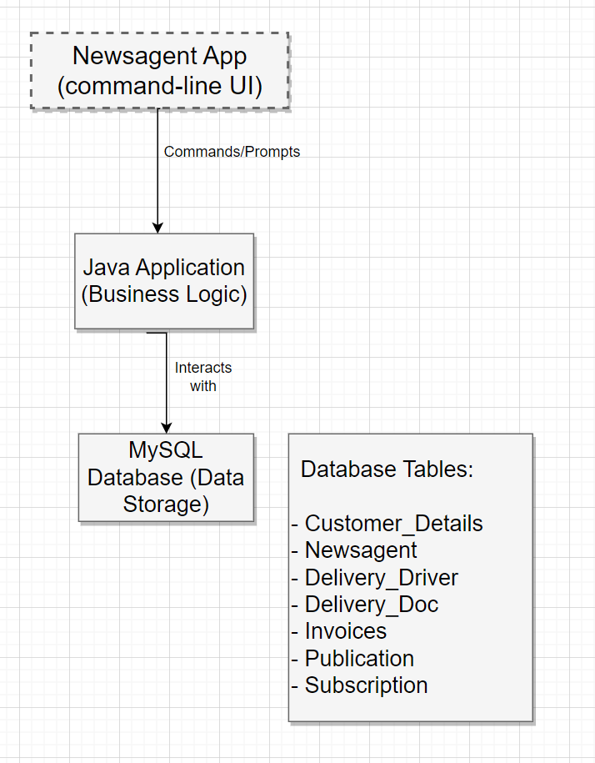

* + Flowchart

Increment 2: Create database (tables) for the entities and test it works as expected.

**Testing:**

1. Run various SQL queries to retrieve/insert/manipulate data
2. Static Test done by another developer

**Database Tables:**

* Customer_Details
  + custID (Primary Key) INT AUTOINCREMENT
  + firstName VARCHAR (15)
  + lastName VARCHAR (15)
  + custAddress VARCHAR (50)
  + phoneNo VARCHAR (13)
* Newsagent
  + newsagentID (Primary Key) INT AUTOINCREMENT
  + username VARCHAR (10)
  + password VARCHAR (10)
  + role (specify role/permission) VARCHAR (50)
* Delivery_Driver
  + driverID (Primary Key) INT AUTOINCREMENT
  + driverPassword VARCHAR (10)
  + deliveryDistrict INT
* Delivery_Doc
  + docID (Primary Key) INT AUTOINCREMENT
  + custID INT
  + publicationID INT
  + dateDelivered DATE
  + FOREIGN KEY (custID) references Customer_Details(custID)
  + FOREIGN KEY (publicationID) references Publication(publicationID)
* Invoices
  + invoiceID (Primary Key) INT AUTOINCREMENT
  + custID INT
  + publicationID INT
  + dateDelivered DATE
  + totalSum DECIMAL (10, 2)
  + invoiceDate DATE
  + FOREIGN KEY (custID) references Customer_Details(custID)
  + FOREIGN KEY (publicationID) references Publication(publicationID)
  + FOREIGN KEY (docID) references Delivery_Doc(docID)
* Publication
  + publicationID (Primary Key) INT AUTOINCREMENT
  + title VARCHAR
  + price DECIMAL (10, 2)
  + quantity INT
  + docID INT
  + FOREIGN KEY (docID) references Delivery_Doc(docID)
* Subscription
  + Relationship -> Customer Details -> Retrieve all details
  + custID
  + subscriptionFrequency VARCHAR
  + custStatus VARCHAR
  + deliveryDisctrict INT
  + startDate DATE
  + endDate DATE
  + FOREIGN KEY (custID) references Customer_Details(custID)

Increment 3:

Testing:

Increment 4:

Testing:

Increment 5:

Testing: